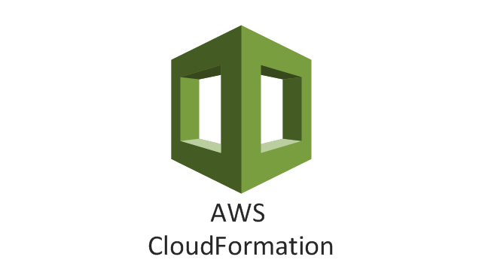

**IAC** stands for ***"Infrastructure as Code,"*** which is a concept and practice in software engineering that involves managing and provisioning infrastructure resources using code and automation.

In the context of cloud computing and DevOps practices, IAC treats infrastructure configurations, deployments, and management as code artifacts, applying principles from software development to infrastructure management.

The primary goal of Infrastructure as Code is to bring the benefits of automation, version control, repeatability, and consistency to the provisioning and management of infrastructure components.

**Key concepts:**

**1. Automation:** IAC automates the process of creating and managing infrastructure, reducing manual intervention, human errors, and repetitive tasks.

**2. Version Control:** Infrastructure code can be stored in version control systems (like Git) alongside application code, enabling collaboration, tracking changes, and rollbacks.

**3. Repeatability:** Infrastructure code is repeatable, meaning you can create identical infrastructure across various environments, such as development, testing, and production.

**4. Consistency:** IAC ensures that your infrastructure is configured the same way every time, reducing configuration drift and maintaining consistency.

**5. Documentation:** Infrastructure code serves as documentation, providing a clear and understandable representation of your infrastructure components.

**6. Scalability:** IAC tools support the management of complex architectures and the ability to scale infrastructure components as needed.

**IAC can be implemented using various tools and frameworks, including:**

**- Configuration Management Tools:** Tools like Ansible, Chef, and Puppet allow you to define and manage the configuration of servers and software.

**- Infrastructure Provisioning Tools:** Tools like Terraform and AWS CloudFormation enable you to define and provision entire infrastructure stacks using code templates.

**- Container Orchestration Platforms:** Platforms like Kubernetes provide infrastructure orchestration and management using declarative YAML or JSON files.

**AWS CloudFormation** is a service provided by Amazon Web Services (AWS) that enables you to define and provision ***infrastructure as code (IAC)*** using templates. Infrastructure as code is an approach that involves managing and provisioning infrastructure resources using code files, which allows for automation, version control, and repeatability.

CloudFormation allows you to create and manage AWS resources, such as EC2 instances, S3 buckets, RDS databases, networking components, and more, by defining their configuration in a JSON or YAML template file. These templates describe the desired state of your infrastructure, including the relationships between resources and any dependencies.

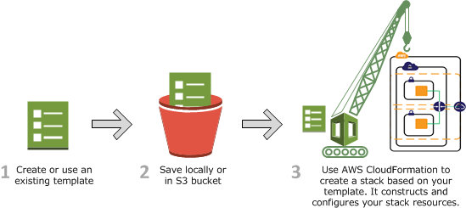

**Key concepts:**

**1. Templates:** These are JSON or YAML files that describe the resources you want to create and their properties. Templates can be written from scratch or generated using CloudFormation Designer, a visual tool provided by AWS.

**2. Stacks:** A stack is a collection of AWS resources created and managed together as a single unit. Stacks are created from templates and can be updated, deleted, or rolled back as a whole.

**3. Resources:** These are the individual AWS components that you define in your template, such as EC2 instances, S3 buckets, IAM roles, and more.

**4. Parameters:** Parameters are customizable values that can be provided when creating or updating a stack. They allow you to make your templates more flexible and reusable.

**5. Mappings:** Mappings allow you to define a set of keys and their corresponding values in your template, which can be used to map different values based on conditions.

**6. Outputs:** Outputs provide information about the resources in your stack that might be useful for other AWS services or for users to know.

**CloudFormation offers several benefits, including:**

**- Automation:** Templates can be versioned, stored in source control, and automatically deployed, reducing manual intervention and increasing consistency.

**- Repeatability:** Infrastructure defined as code can be easily replicated across environments, ensuring consistency between development, testing, and production environments.

**- Scalability:** CloudFormation supports complex architectures and allows you to manage large and interconnected resource configurations.

**- Rollback and Recovery:** In case of errors during stack updates, CloudFormation can roll back to the previous known working state.

**- Visibility:** Templates provide a clear and documented view of your infrastructure, making it easier to understand and manage.

AWS CloudFormation Templates:

<https://github.com/javabyraghu/CloudFormationTemplates>

AWS CloudFormation Examples:

<https://docs.aws.amazon.com/AWSCloudFormation/latest/UserGuide/sample-templates-services-ap-south-1.html>

**JSON**

JSON, which stands for JavaScript Object Notation, is a lightweight data interchange format that is easy for humans to read and write, and easy for machines to parse and generate.

It is widely used for representing structured data and exchanging information between a server and a client, as well as for configuration files, APIs, and more. JSON is often used in web applications, APIs, and data storage formats.

JSON syntax is simple and consists of key-value pairs, where keys are strings and values can be strings, numbers, boolean values, arrays, or nested objects. Here's a basic example of JSON:

**{**

**"name": "John Doe",**

**"age": 30,**

**"isStudent": false,**

**"hobbies": ["reading", "hiking", "coding"],**

**"address": {**

**"street": "123 Main St",**

**"city": "Anytown",**

**"country": "USA"**

**}**

**}**

**JSON is commonly used in various contexts, including:**

**- API Responses:** Many APIs use JSON to format their responses, allowing clients to easily parse the data and integrate it into their applications.

**- Configuration Files:** JSON is used for configuration files in applications and systems to store settings and preferences.

**- Data Storage:** JSON is often used in NoSQL databases and document-oriented databases to store structured data.

**- Web Applications:** JSON is used to exchange data between the frontend and backend of web applications.

**- Interchange Format:** JSON is used for data interchange between different programming languages and platforms.

**YAML**

YAML (short for "YAML Ain't Markup Language" or "Yet Another Markup Language") is a human-readable data serialization format. It is often used for configuration files and data exchange between languages with different data structures. YAML is designed to be more human-friendly and easier to read than other serialization formats like JSON or XML. It's commonly used in scenarios where clarity and readability of the configuration or data are important.

YAML syntax uses indentation to define the structure of data. Unlike JSON, YAML relies on whitespace indentation to indicate nesting and hierarchy. Here's an example of YAML:

**name: John Doe**

**age: 30**

**isStudent: false**

**hobbies:**

**- reading**

**- hiking**

**- coding**

**address:**

**street: 123 Main St**

**city: Anytown**

**country: USA**

**Key features of YAML include:**

**- Readability:** YAML is designed to be easy for humans to read and write, with minimal punctuation.

**- Conciseness:** YAML's concise syntax reduces the amount of noise compared to formats like JSON or XML.

**- Comments:** YAML supports comments, allowing you to add explanatory notes within the configuration.

**- Support for Various Data Types:** YAML supports various data types, including strings, numbers, booleans, arrays, objects, and more.

**YAML is commonly used in various contexts, such as:**

**- Configuration Files:** Many applications and systems use YAML for configuration files due to its readability and conciseness.

**- Docker Compose:** Docker Compose uses YAML to define the configuration of multi-container Docker applications.

**- Kubernetes:** Kubernetes uses YAML files to define the configuration of resources like pods, services, and deployments.

**- Continuous Integration/Continuous Deployment (CI/CD):** CI/CD pipelines often use YAML for defining build and deployment processes.

While YAML is popular and widely used, it's important to note that its indentation-based syntax can sometimes lead to errors if not formatted correctly.

**FAQs**

**1. What is AWS CloudFormation?**

AWS CloudFormation is a service that allows you to define and provision AWS infrastructure resources using templates. It enables you to manage your infrastructure as code, providing automation, consistency, and repeatability.

**2. What is a CloudFormation template?**

A CloudFormation template is a JSON or YAML file that describes the AWS resources you want to create and their properties. Templates are used to define the infrastructure you want to provision.

**3. What is a stack in CloudFormation?**

A stack is a collection of AWS resources created and managed together. Stacks are created from CloudFormation templates and can be updated, deleted, or rolled back as a whole.

**4. How do I create a stack in CloudFormation?**

You can create a stack using the AWS Management Console, AWS Command Line Interface (CLI), or AWS SDKs. You provide the CloudFormation template and any required parameters to create the stack.

**5. What are CloudFormation parameters?**

Parameters are values that you can pass to your CloudFormation template at runtime. They allow you to customize your stack without modifying the template itself.

**6. What are CloudFormation outputs?**

Outputs are values from your CloudFormation stack that you can retrieve and use. They can be useful for obtaining information about created resources, such as URLs or resource IDs.

**7. What is CloudFormation drift detection?**

CloudFormation drift detection helps you identify differences between the desired stack configuration (as defined in the template) and the actual deployed resources. It can help you maintain stack consistency.

**8. What is the rollback policy in CloudFormation?**

The rollback policy determines how CloudFormation handles updates that fail. You can configure CloudFormation to roll back to the previous stack state in case of a failure.

**9. What is the difference between an update and a replacement in CloudFormation?**

An update involves modifying an existing resource without replacing it. A replacement occurs when CloudFormation must replace a resource (e.g., changing instance types). CloudFormation handles these changes based on the resource's update behavior.

**10. What is CloudFormation StackSets?**

CloudFormation StackSets allow you to create, update, or delete stacks across multiple accounts and regions with a single CloudFormation template.

**11. How can I secure my CloudFormation stacks?**

You can use AWS Identity and Access Management (IAM) policies to control who can create, update, or delete CloudFormation stacks. Additionally, you can use AWS CloudFormation Stack Policies to control updates to stack resources.